SOLIDWORKS® PDM Professional

2018 Training Vault Setup

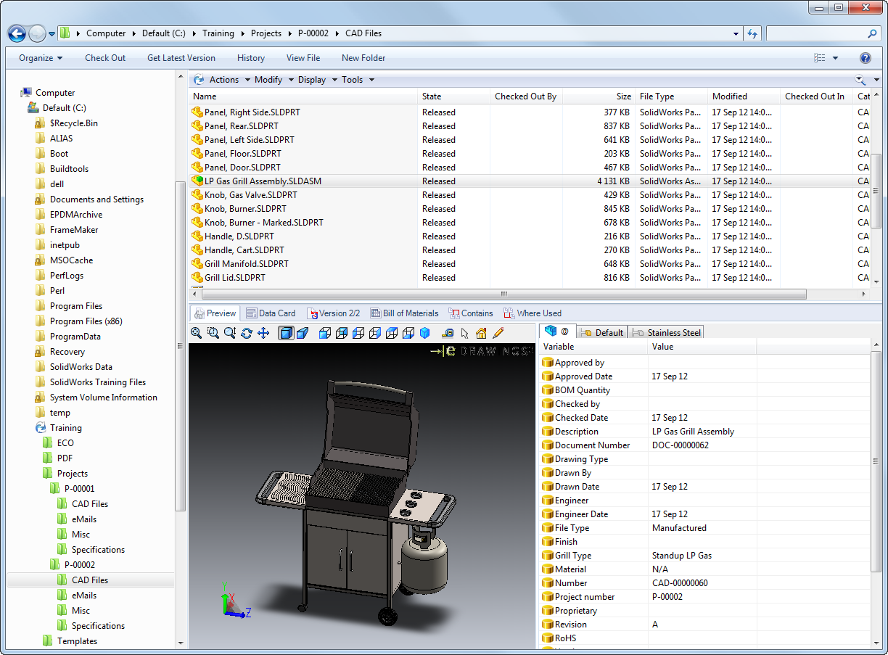

**Setup Instructions**

Follow these instructions to install the vault for the SOLIDWORKS PDM end user training.

**Prerequisites:**

* Proficiency with SOLIDWORKS PDM software.
* SQL Server, SOLIDWORKS PDM Database Server, SOLIDWORKS PDM Archive Server and SOLIDWORKS should already be installed on the server machine
* SOLIDWORKS, SOLIDWORKS PDM CAD Editor client and SOLIDWORKS Composer Player should already be installed on each client machine.

1. **Create a new SOLIDWORKS PDM file vault and a corresponding SOLIDWORKS PDM view.**
   1. In the Administration tool, right-click the archive server, select **Create new vault**, and name the vault **ACME**.

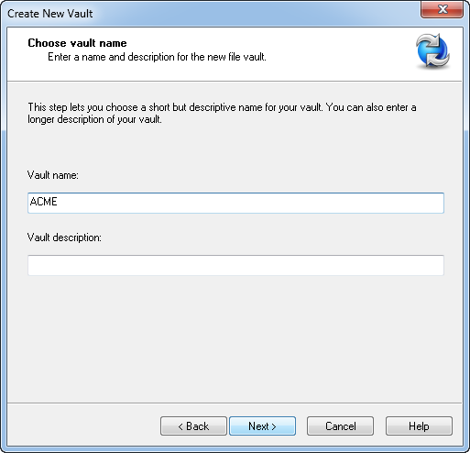

* 1. Ensure this is a **PDM Professional Server.**
  2. Continue vault creation: select appropriate language and date format:

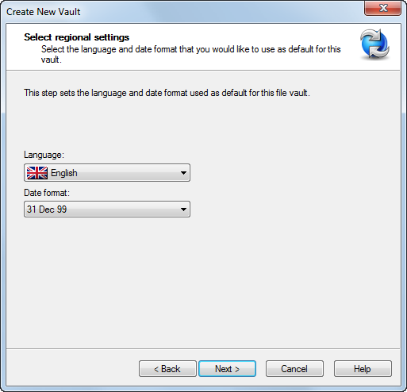

* 1. When you get to the **Configure vault** dialog, select Use a standard configuration and select **Empty**.

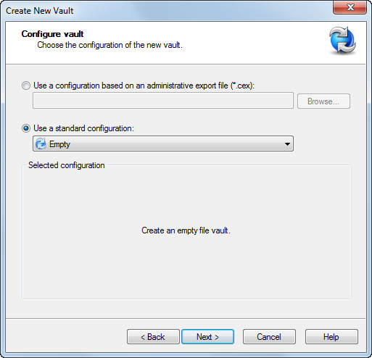

* 1. Continue until vault creation is completed.
  2. Once the file vault has been created, log in as the **Admin** user.
  3. If you have not already done so, attach PDM to the appropriate license server.

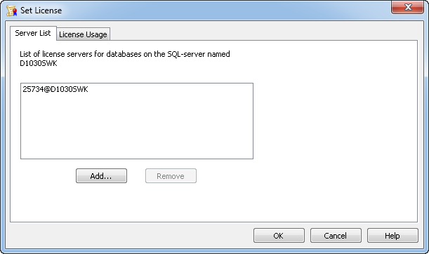

* 1. Right-click the file vault name and select **Create Local View**. Place it on your local C drive (or wherever appropriate) and ensure you “make it accessible to all users”.

1. **Import vault setup.**
   1. In the Administration tool, right click on the **Training** vault and select **Import.**

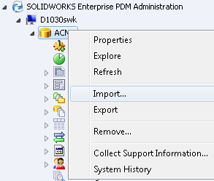

* 1. Select the file **2018TrainingVault.cex** and select **Open**.
  2. Answer **‘Yes to all’** if prompted to overwrite current values.
  3. Click **OK** to complete import.

1. **Assign permissions for the Management Group.**

When the groups are created, their workflow permissions will be set, but you must assign their folder permissions.

* 1. In the Administration tool, expand **Groups** and double-click **Management**.

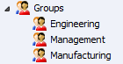

* 1. Set the **Column view** to **Explorer-MGR**.

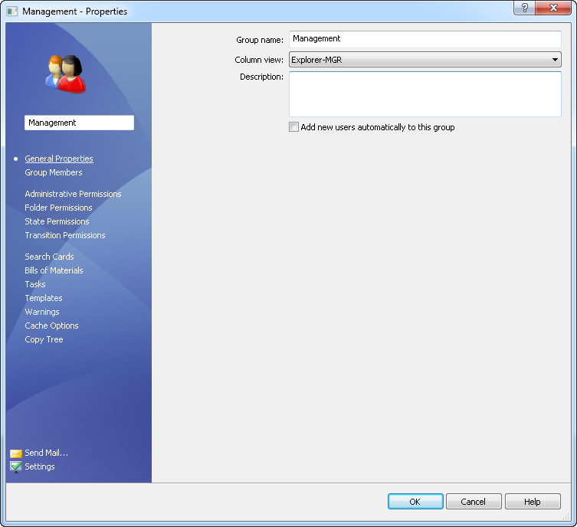

* 1. Select the **Folder Permissions** then select the file vault root. Select all the items under **Folder Permissions**.

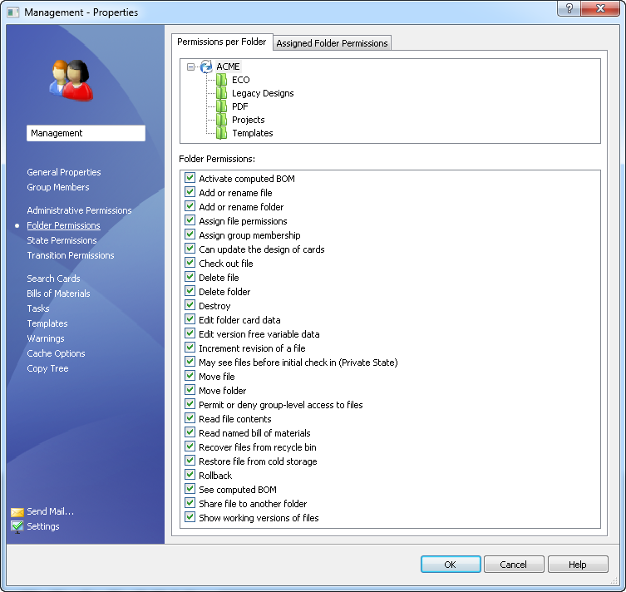

1. Click **OK** to save.
2. Set permissions for project template.
   1. Double-click **Create ACME ECO** to edit the template.
   2. Select **Execute as** and select **Read permissions from the following user:** and set **User name:** to **Admin**.

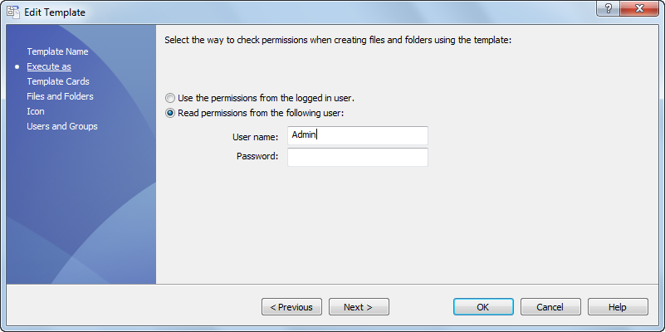

* 1. Select **Users and Groups** and check the **Admin** user.

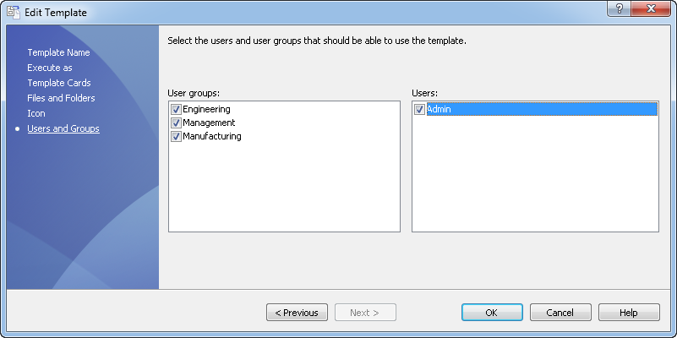

* 1. Click **OK**.
  2. Repeat the procedure for all Templates.

1. **Create Users for the vault based on the attendees of the course**
   1. Create “Engineer” users for each attendee of the course
   2. Create “Manager” users based on the manager of the attendees for the course. If this information is not available, create your own list of “Managers” or import the **2016Managers.cex** file.
2. **Populate vault with project folders and files.**
   1. Open Windows Explorer and login into the **ACME** vault as **Admin**.
   2. Right-click in the file view and select **New ACME Project**.

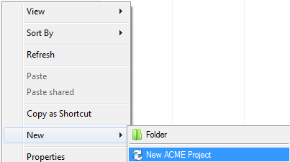

* 1. Select **DS Woodland Hills** for Customer, select someone from the management group for Project Manager, select **Standup LP Gas** as Grill Type and select **564 Sq In LP** as Grill Size.

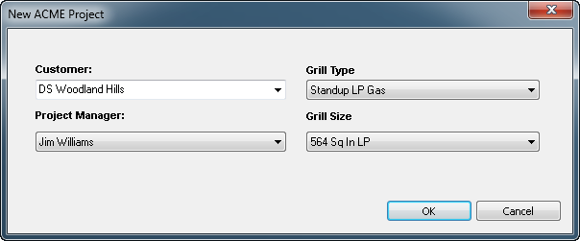

* 1. Right-click in the file view and select **New ACME Project**.
  2. Select **DS Waltham** for Customer, select someone from the management groupfor Project Manager, select **Standup LP Gas** as Grill Type and select **530 Sq In LP** as Grill Size.

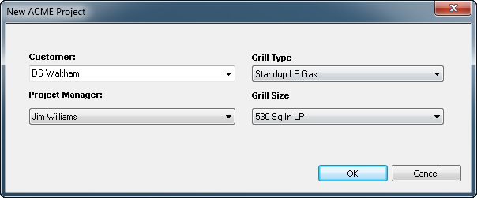

* 1. Right-click in the file view and select New Acme Project.
  2. Select **DS Waltham** for Customer, Select **Betty Black** for Project Manager, select **Portable LP Gas** for Grill Type and **230 Sq. In. LP, Portable** for Grill Size.



* 1. Open a second Explorer window and browse into the **Vault Files** directory (part of the vault setup files).
  2. Copy the folders **P-00001** and **P-00002** to **Projects**. Select **Yes to All** when prompted.

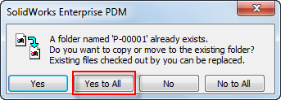

* 1. Right-click the **Projects** folder and select **Check In**. (Ignore the 6 warning messages)
  2. Make sure all files are selected and click **Check In** to complete the check in of the training files to the vault.
  3. Right-click the **Projects** folder and select **Change State**, then **Data Migration**. Complete the change state.
  4. Select the **Projects** folder, then select the **Modify** menu and **Set Revision**.
  5. Right-click in the **Set Revision** dialog and select **Set All New Revision Values to Card Variable Value**. Click **Ok** to complete the **Set Revision** process.
  6. Copy the **Templates** folder into the root level of the vault. Select **Yes to All** if prompted.
  7. Right-click the **Templates** folder and select **Check In** to complete the check in of all of the template files.

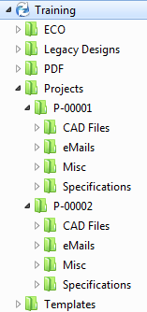

1. **Assign permissions for the Engineering and Manufacturing Groups.**

When the groups are imported, their workflow permissions will be kept, but you must assign their folder permissions.

* 1. In the Administration tool, expand **Groups** and double-click **Engineering**.



* 1. Set the **Column View** to **Explorer-ENG**.

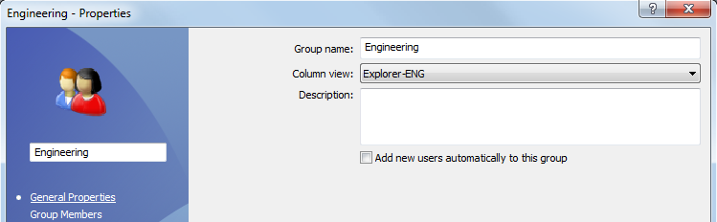

* 1. Select **Folder Permissions** and select the folder **Projects**. Select everything under **Permissions** ***except****:*
     + **Assign file permissions**
     + **Assign group membership**
     + **Can update the design of cards**
     + **Set Revision**
  2. Select **Folder Permissions** and select the folder **Legacy Designs**. Select everything under **Permissions** ***except****:*
     + **Assign file permissions**
     + **Assign group membership**
     + **Can update the design of cards**
     + **Set Revision**
  3. Select the folder **ECO**. Select everything under **Permissions** ***except****:*
     + **Add or rename a folder**
     + **Assign file permissions**
     + **Assign group membership**
     + **Can update the design of cards**
     + **Delete Folder**
     + **Destroy**
     + **Set Revision**
     + **Rollback**
  4. Select the folder **PDF**. Select everything under **Permissions** ***except****:*
     + **Add or delete a folder**
     + **Assign file permissions**
     + **Assign group membership**
     + **Can update the design of cards**
     + **Delete Folder**
     + **Destroy**
     + **Set Revision**
     + **Rollback**
  5. Click **OK** to save.
  6. In the Administration tool, expand **Groups** and double-click **Manufacturing**.



* 1. Select **Folder Permissions**, select the vault root level folder and select *:*
     + **Read file contents**
     + **Show working versions of files**
  2. Select the folder **Templates**. Uncheck all checked boxes.
  3. Click **OK** to save.

1. **Set List Properties**

There is a list that queries the vault database to return a project number. It must be modified to work with your training server.

* 1. In the Administration tool, expand **Lists** and double-click **Project Number**.
  2. Set the **Server**, **Database**, **Login** and **Password** fields to match your training server.

Note: The login and password fields refer to the SQL Server credentials. (ie: sa)

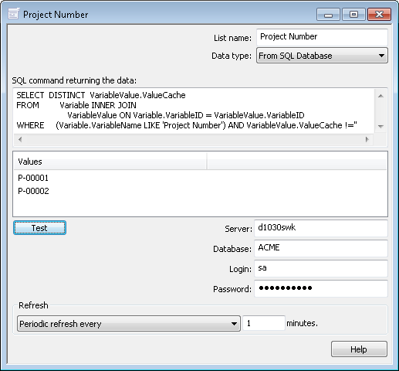

* 1. Click the **TEST** button to ensure the query is working correctly
  2. Click the **Save** icon in the upper left hand corner of the Administration tool to save the changes and close the dialog window.

1. **Set Users Settings**
   1. In the Administration tool, right-click **Users** and select **Settings**.

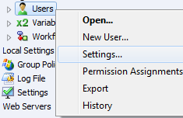

* 1. Select **Explorer** from the menu on the left, for **File types to show:** select **Show only files that are part of the file vault.**

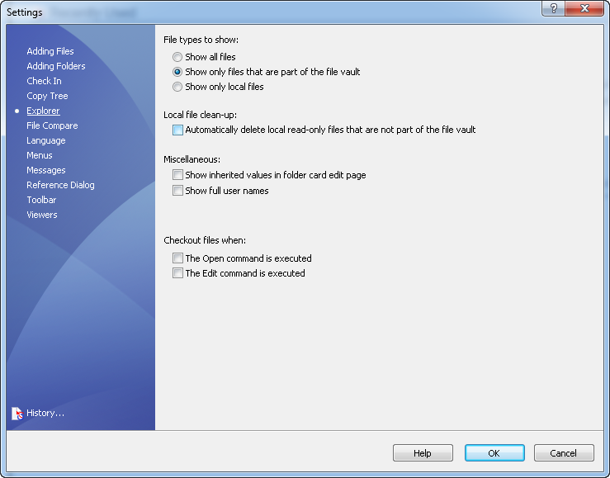

* 1. Select **OK** to save selection.

1. **Setup Convert Task.**

Setup of tasks will be done of the server machine which MUST have SOLIDWORKS installed. (SOLIDWORKS is used to perform PDM conversions).

While the SOLIDWORKS Task add-in could be saved as part of the export, it is better to import and configure the add-in separately in order to ensure that the latest version is being utilized. (The same would apply to the Dispatch add-in if used.)

* 1. In the task tray, select the Enterprise ‘blueberry’ and select **Task Host Configuration**.

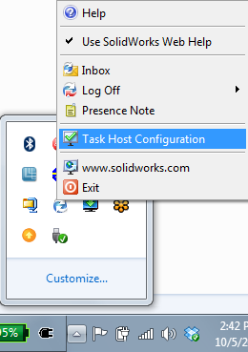

* 1. In the **Task Host Configuration** dialog, check **Permit** for the **Training** file vault and select **OK**.

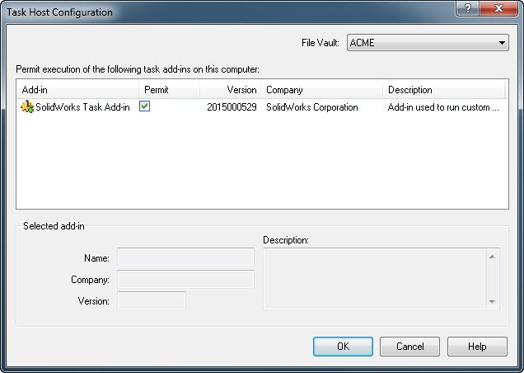

* 1. In the Administration tool, expand Tasks, double-click on **Convert**, select **Execution Method**, check the machine name and click **OK** to save.

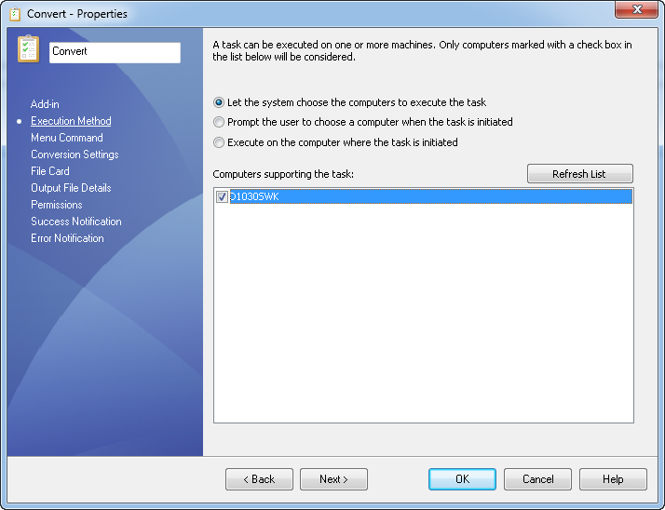

**TIP: To make setup for future classes easy, back up the vault and use the backup to setup the vault. Information on backing up and restoring a vault can be found in Lesson 12 of Administering SOLIDWORKS PDM manual.**